AYS – At Your Service
Management Training

Administrative Training

Adding Your Staff/Logging In

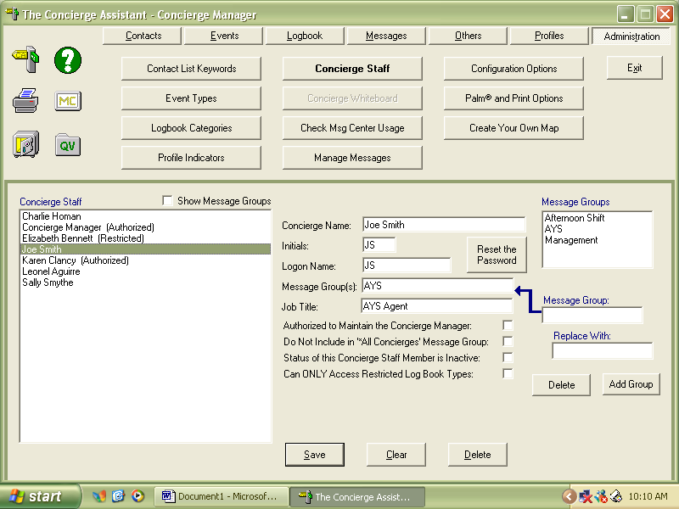

Message Groups
Most properties delete the message groups morning, afternoon and evening shift due to many employees do not work set shifts.
Instead they create message groups that are department specific, so nothing falls through the cracks.

All Staff should not have authorization to maintain Concierge Assistant only the Manager of the Department.

Their logon name will be the name or initials that your agent will use to get onto the system. The first time that they logon they will use this logon twice it will then prompt them to “create a new Password”, this is the password they will use from now on.

Hint: make everyone’s logon similar, i.e., initials (as above) first initial last name (jsmith) or their first name (Joe).

The only password that your agent CANNOT use is the same as their logon name. When they log into the system they will put their logon name twice once in the logon and once in the password field. The computer will then prompt you to then put in your password as shown below:

On the initial logon DO NOT let them hit Change password, this will make entry into the system impossible and they will have to be deleted from the system and a new logon will have to be created.

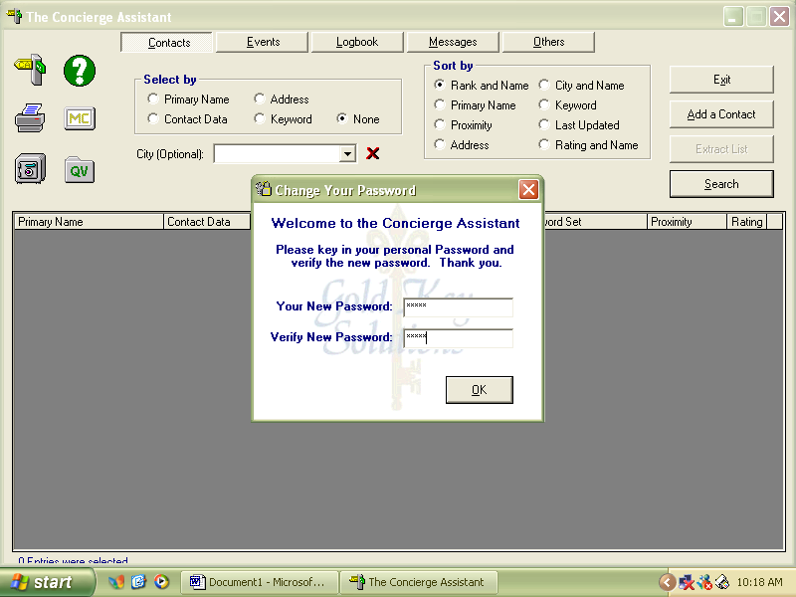

Once they put their logon on name twice (on the initial logon) they will then get this next prompt to create a new password – they will put the password in twice and hit OK.
Staff Logon Sheet

Name | Logon Name | Position | Status * | Msg Grp
Karen Clancy | Kclancy | Trainer | Authorized | Management

Creating Your Contact Keyword Lists for your Bible

Keywords are used to group categories together.
Please note: do this early in the first training session so that all the keywords will be entered prior to your staff learning how to “Add a Contact” training.

The first tab in the Administrative function of The Concierge Assistant is Contact Keyword List. There are approximately 350 words there upon installation of the program. All of the keywords can be changed, deleted or new ones can be added depending on your needs.

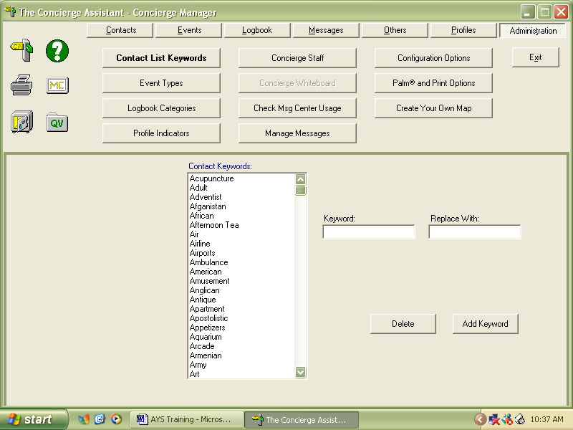

It is now time to go through your bible and use the exact keywords that are in your bible. This will make it easier on you and your staff in acclimating to the system. Each tab that you have in your bible should be a new Keyword.

Some that have been used in the past that are not already in the system:
Emergency Procedures, Local Restaurants, Directions
Your entire Department lists. I.e. Accounting, Loss Prevention, Security, AYS
Bible (for everything that is going into the Bible, so you can bring up everything in your bible at once so you can make a hard copy of it).

Contact Keyword Log sheet

Bible Tabs | In Concierge Assistant
Emergency Procedures
Local Restaurants

Logbook Categories

The Logbook is to log all guest communications and requests.

Some examples of Logbook Categories for AYS are:
Fax Log Sheet
Package Log Sheet
Dining Reservations
Shuttle Requests
Taxi Requests
Wake up Calls
Newspaper Requests
Guest Inquiry/requests

To Personalize your Logbook Categories:

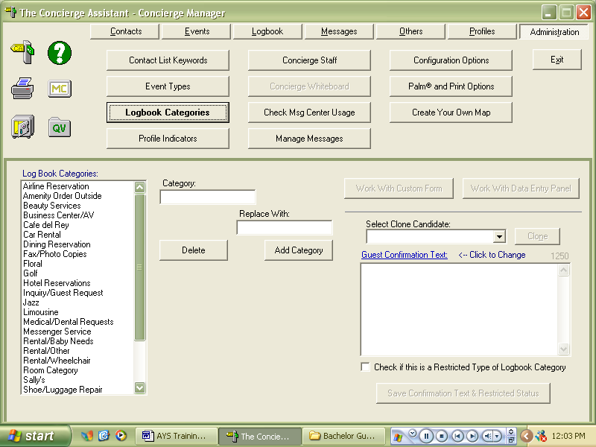

To add a new category:

In the category field add the new category, i.e. Fax Log Sheet and strike “Add Category” button.
You then will go and “pick-up” the new category and then strike the button “Work With Data Entry Panel” once you have hit that button you will see this screen:

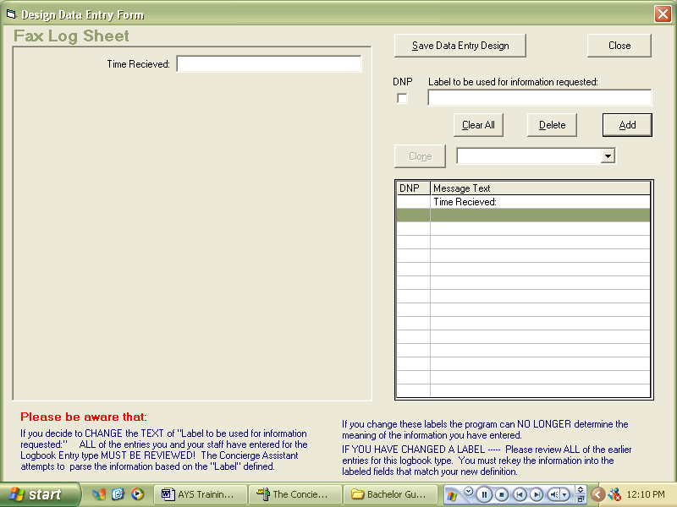

At this point you will mock you existing Fax Log sheet into the appropriate cells.

Remember: Guest Last Name, First Name, Room Number, Arrival Date and Reference Date, will already be on the left-hand side of the data entry panel (so there is no need to add them into the data entry panel).
Time is also a consideration, the computer will automatically put in the date and time that the entry but if faxes are not getting logged immediately you might want to have that cell provided. It is always better to have more cells than needed; if they are not used they will not print out.

Once all the cells are added then strike the “Save Data Entry Design” Button.

When an entry is done this is what it will look like:

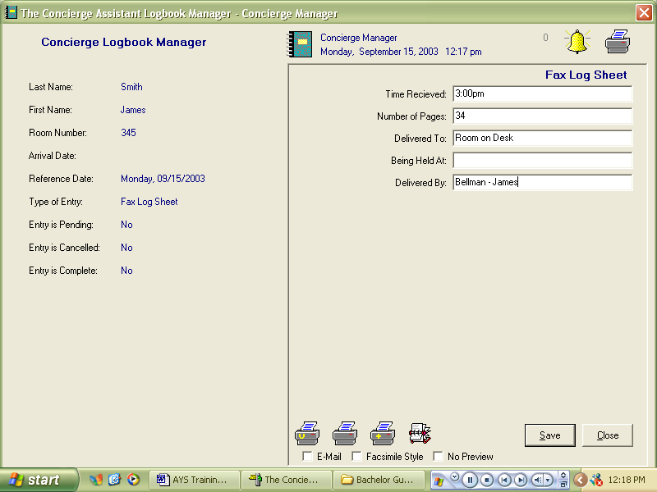

You can create as many logbook categories as needed.

Profile Indicators

If you are using the Marsha Interface you will need to set the profile indicators so it will interface with MARSHA.
In the profile indicators put them in as follows:

All Preference Type and Sequence Numbers need to match in order for the MARSHA interface to work.
Preference Type | Sequence
Confirmation Number | 10
Marquis Level | 20
Rewards Number | 30
Fulfillment Flag | 40
First Stay Flag | 50
Reservation Count | 60
Arrival Date | 70
Departure Date | 80
Reservation Date | 90
Number of Nights | 100
Rate Basis | 110
Number of Rooms | 120
Party Size | 130
Experience ID | 140
Market Segment | 150
Rate Code | 160
Special Interest Codes | 170
Special Occasion Codes | 180
Special Request Code | 190
Children's Ages | 200

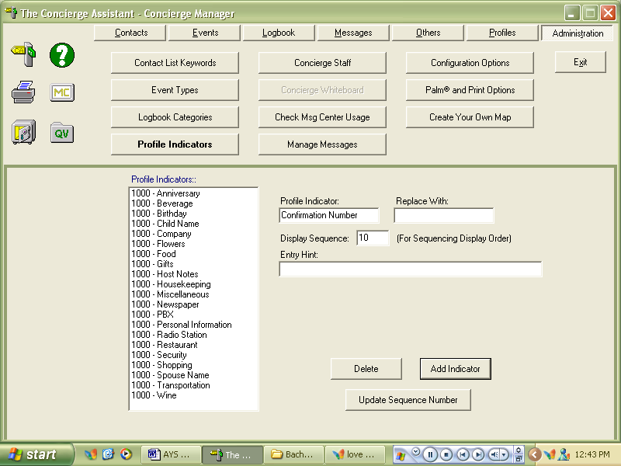

Strike “Add Indicator” Button to then add the new indicators.

Others Tab

The Work With the Rental and “Need-it-Now items are to eliminate the use of the Cork board for things that guests are using.
This could be anything from Microwaves, rollaway beds, games, umbrella ect.

The main thing that AYS uses from the “Other’s” Tab is the “Work With the Rental and “Need-it-Now” Inventory Items”

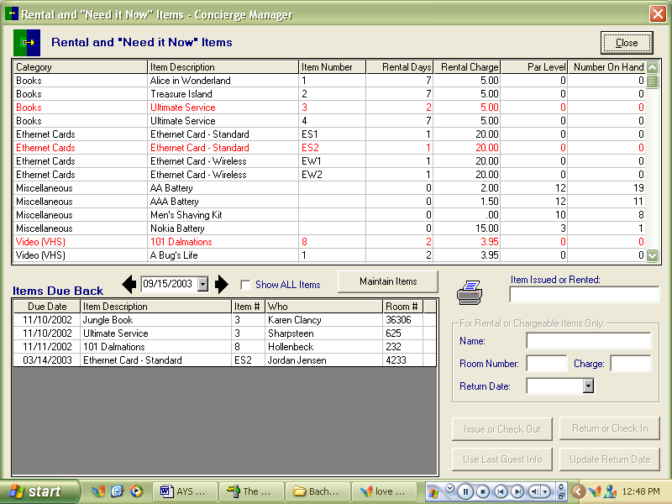

The first thing you have to do is your inventory.
Go to the button that is located in the middle of the screen called “Maintain Items”.
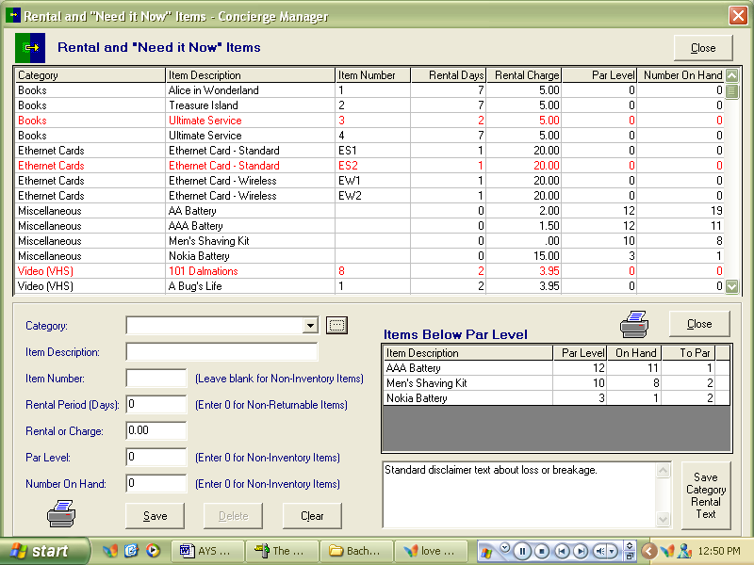

Click on to the Box with three little dots in it.
This will bring up your category box to be able to start logging your inventory.

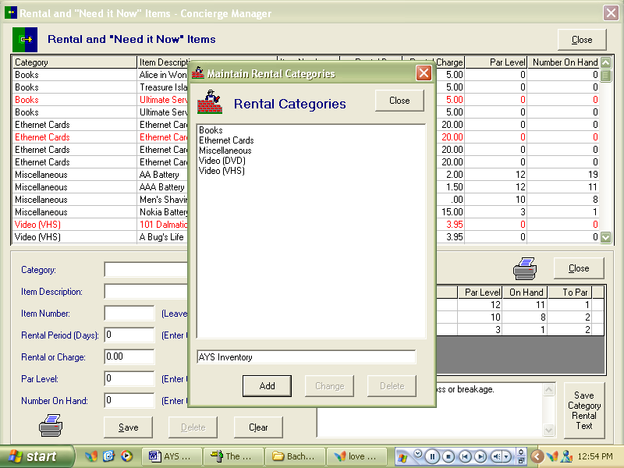

Add as many categories that your property requires. You can either do it by department or by location of items.
For each new category you must then strike the “Add” key.

Once the new categories have been added, it then will appear in the category drop box.

All of the following boxes MUST be filled out in order for the item to be rented out.
Category
Item Description
Item Number
Rental Period (Days)
Rental or Charge – (you can put .01 for a non chargeable item)
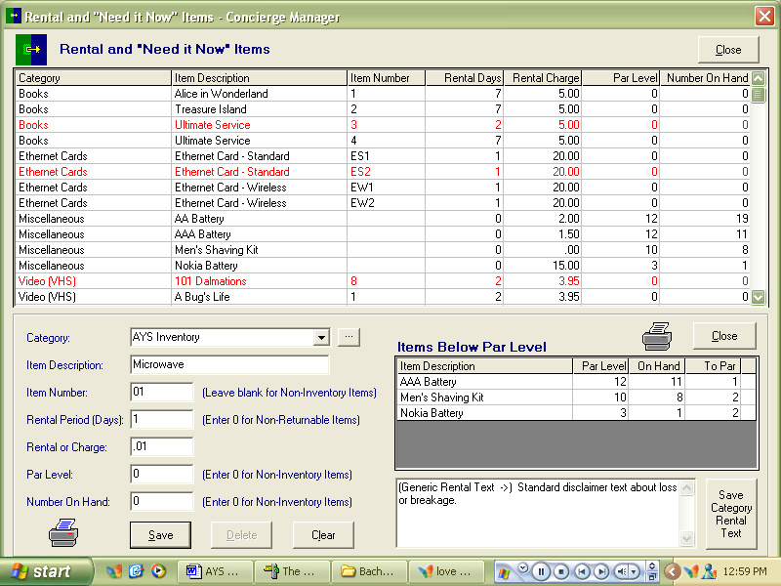

Items that are “Checked out” will appear in Red.
They will then appear in the box when they are to be returned back.

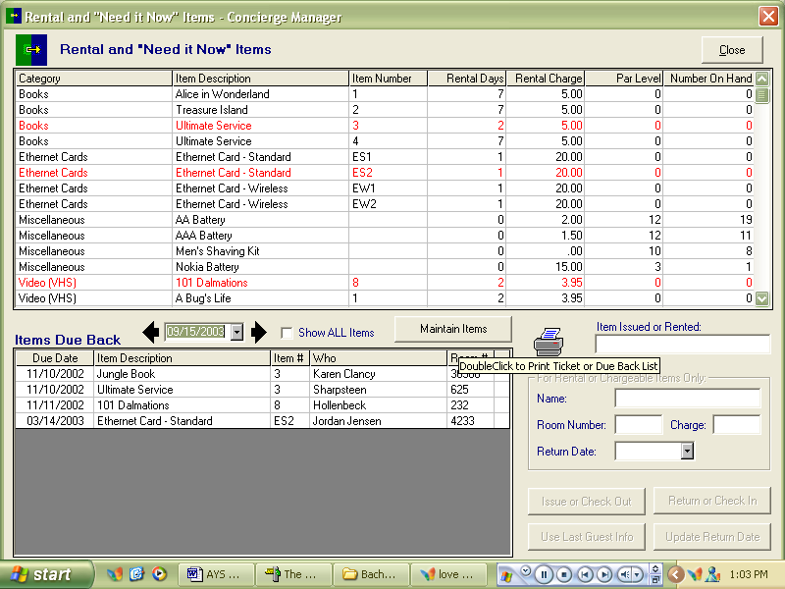

This printer will then print out a list for you to be able to contact the guest or to send a houseman up to retrieve the items.

AYS Agent Training

Overview of The Concierge Assistant

The Concierge Assistant is a very intuitive application and is written in a way that if you know one screen (or Tab) you will understand the whole application.

All three major “Look up” Screens are similar in design and layout. Contact, Events and Logbook all have 3 things in common.

- A large Select by Box to initiate your search—this is how you will begin your search with very little information from the guest.
- A second box to the right that is a Sort Box to define your search even further.
- There are two more boxes to the right that are also the same: the add button and the search button.
Add Button: When you want to add a contact, event or logbook entry
Search Button: When you want to refresh the screen to look for your new search

Contacts:

The Contacts Tab of The Concierge Assistant is a large rolodex with a search engine attached to it. This will have your whole Bible in it. Everything from your In-house employee list to your emergency procedures.

When you first initiate your look up you will click one of the radio buttons listed:
Primary Name
Contact Data
Address
Keyword
None

You will then type in the information that you have into the field that is provided.
Please take note of the City (Optional) field, you will usually type it in the box that is below the city optional box. The City optional box is if you wanted to limit it to that one city.

Example:
A guest requests a phone number of a nightclub he went to 6 years ago and all he knows is that the club has blue in its name.

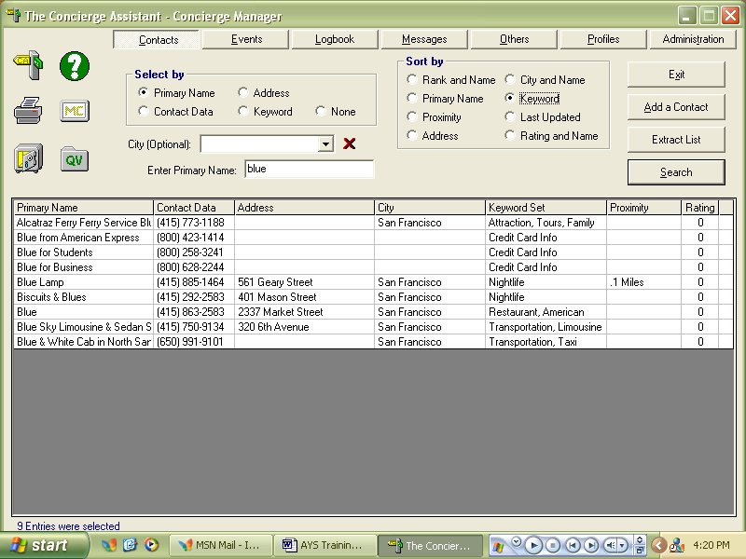

You will select on Primary Name radio button and enter blue; you will then click on the keyword button in the Sort By box to define your search.
You will then be able to give the guest the information.

A similar search can be done from every field, the address field can be used if the guest needs to locate a bank on a certain street.
Example: A guest needs to find a bank on Main Street. You would then click on the Address Radio Button and then enter the address (usually just the street name) and then refresh the screen by the either hitting your enter key or the search button.

If you are trying to check a number use the Contact Data radio button, put in the last four digits and it will bring up the number.

Keyword Search:
This is if you want to bring up a whole category, i.e. Church will bring up all of your Churches.
You will also be able to print out church lists or any lists that are in the system.

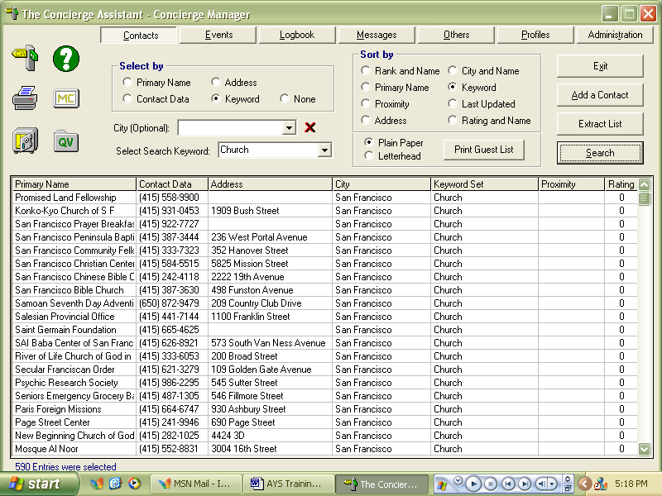

Then press the button “Print Guest List” Button to then print the list
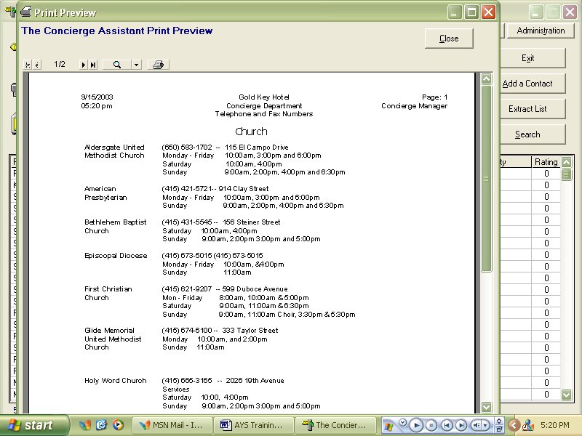

To Add a Contact:

Go to your “Add a Contact” and click your mouse.
You will then get a blank Data Entry Screen.
Fill in with the appropiate information
Contact data is either the phone number or the extension of the contact.
If you are inputting your in-house list use the address field for the title of the person.
Keyword or Services Field
This is probably the trickiest one. In order to assign Keywords or Services you must put your cursor in the box til it becomes the (I) and then double click.
You will bring up your Contact Keyword List to choose from.
FYI: You Cannot type in the keywords that you want you must choose them from the list.
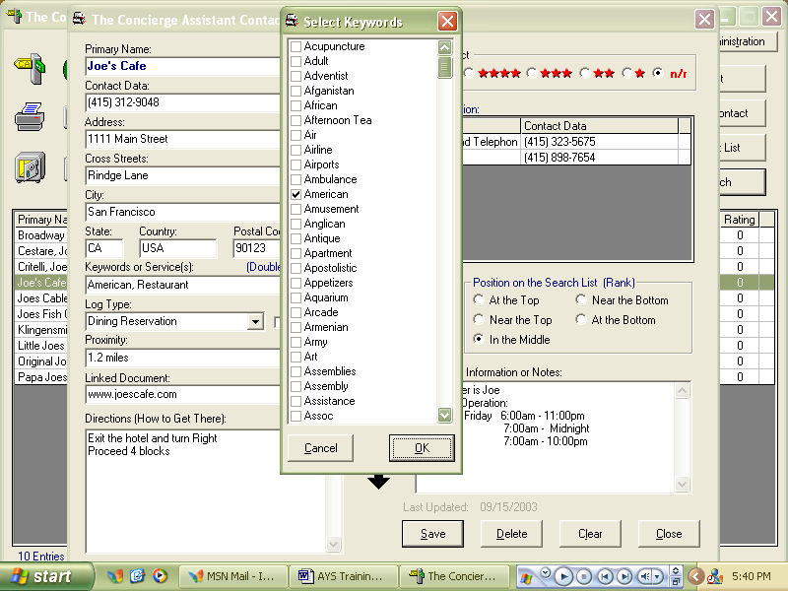

Log Type is if there is a Logbook Data entry panel that will go with it, i.e. This is a Restaurant so Dining Reservation would be the type of “Log Type” Associated with it.

Proximity is the distance from the hotel, you must be consistant in how you enter this information, if you enter in miles it all must be in miles so you can sort by miles in the look up fields.

Linked Document is used to either link a website or to link a document.
To link a website just put in the website address into this field.
To link a Document, the document must be on a share drive; Once it is on the share drive you will click on the small box to the right of the Linked Document field:

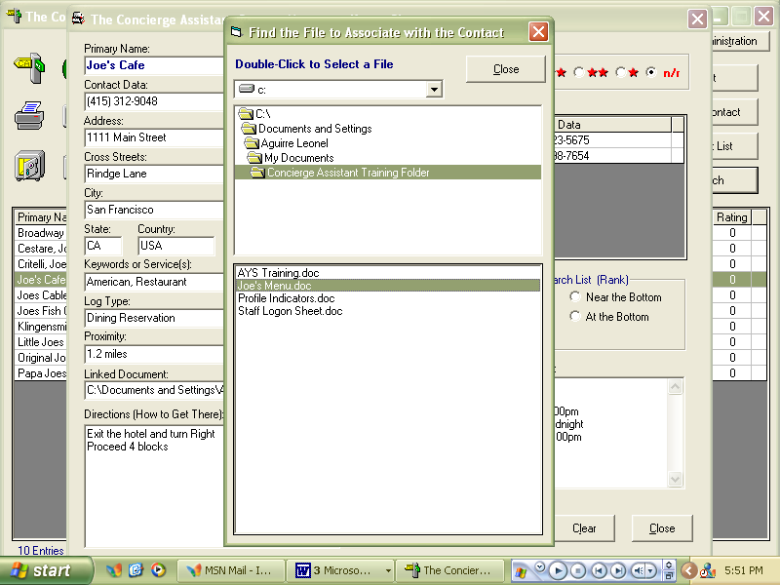

If you have a scanned menu on the share drive or any documents that have already been created you can link it to have immediate access to the document.

Please note: you only have to link each document once, and they MUST be on a Shared Drive.

You will then double click the earth with 2 computers to then view the document.

Also, you are able to copy and paste from any website into The Concierge Assistant.

The Logbook

Explanation of the Main Logbook Screen

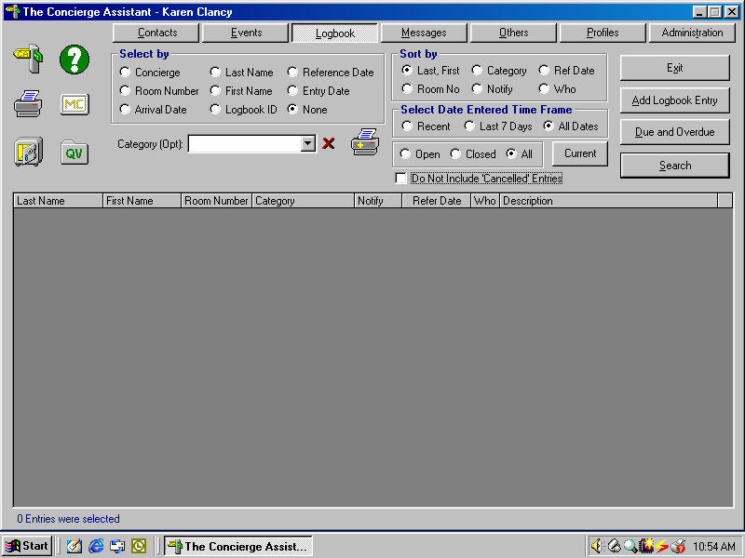
Select by Box is the first thing to choose when starting your search function.

Select By

- When you are beginning your search for entries you must always select by first.
  - Concierge it will automatically bring up the name of the concierge that is logged on to the program. By either using the drop down arrow or by beginning to type you are able to select any concierge that has a log on in the system.
  - Room Number will bring up a cell that you will then type the guest’s room number in and any guest that has been in that room since you have archived will come up.
  - Arrival Date when putting arrival dates into the field in the guest reservation it will bring up every guest that has that corresponding arrival. This is great if you are printing up itineraries for incoming guests.
  - Last Name when the guest approaches the desk you can bring it up by the last name of the guest. A best practice is to only put a few letters of the last name of the guest to try to avoid misspelling of the guest’s last name.
  - First Name if you know the guest’s first name to try to recall what the guest has done during their stay.
  - Logbook ID every single logbook entry has a unique identifier number located at the top right-hand side of the logbook entry (by the bell and the printer in grey), this number can be used to give to either guests who are insistant on having a confirmation number or to be used as a voucher number.
  - Reference Date is the way most properties run the application from day to day. When you bring it up by reference date for today’s date it will bring everything up that is happening that day.
  - Entry Date is the date that the entry has been made by the Concierge. That Date Appears at the top of the data entry page.
  - None using the None box is a best practice for finding out what is still open in the system. Click on None and to the lower right next to your Search key there are three buttons Open, Closed All. If you select on the Open button it will bring everything up in the system. As Shown:

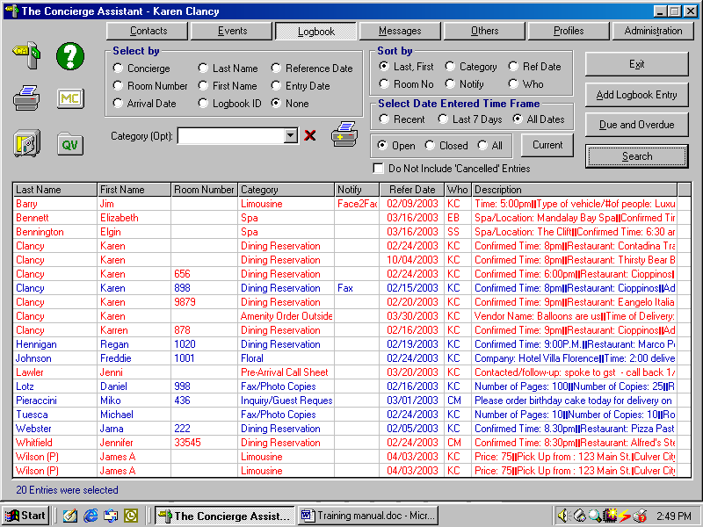

To see all your OPEN entries

Making a New Reservation in CA

- Login
- Click on Logbook
- Click on Add Logbook Entry
- Follow fields as Shown

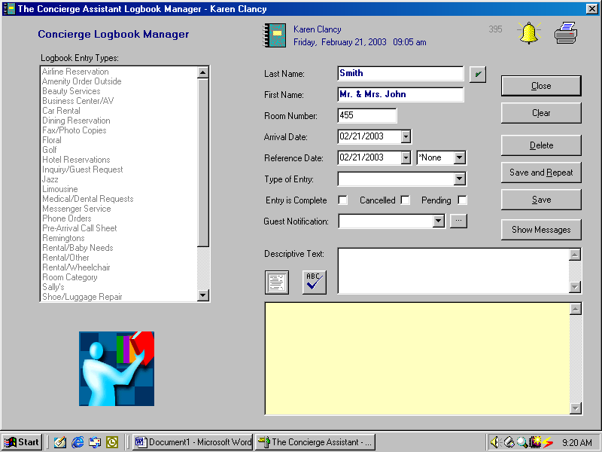
Drop down Calendar

- Arrival Date is the date the guest will be arriving in the hotel. Please use the drop down calendar to eliminate any errors.
- Reference Date is the date the guest wants the reservation for. Please use the drop down calendar to eliminate any errors.
- The *none box is only used for sequencing itinerary items please see page () for explanation.
- The best way to navigate through the system is to use the tab key, if you use the enter key it is going to take you back to the beginning of the entry. But, you can always use your mouse also.

- Type of Entry is going to tell the computer which kind of reservation you are going to be making for the guest, i.e. Dining Reservation.
  - There are 3 ways to obtain Logbook entry types 1. Start typing and the computer will automatically recognize the entry. 2. Use your drop down menu and click on to the type of entry. 3. In the large box to the right double click on the appropriate entry and it will shoot over to the right.
- Tab Four Times to get down to the descriptive text box to bring up the next window (data entry panel).

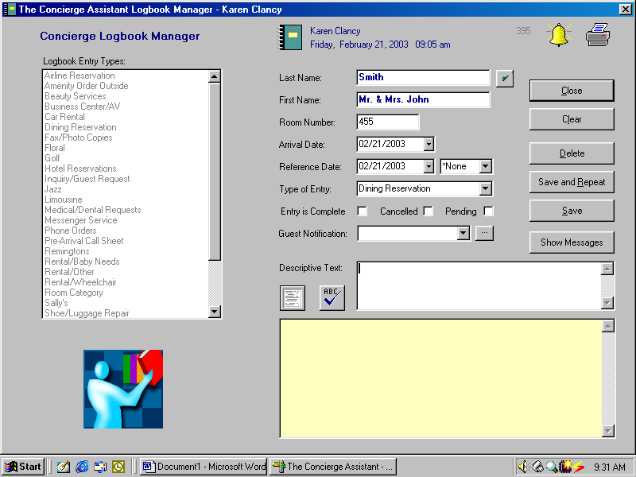

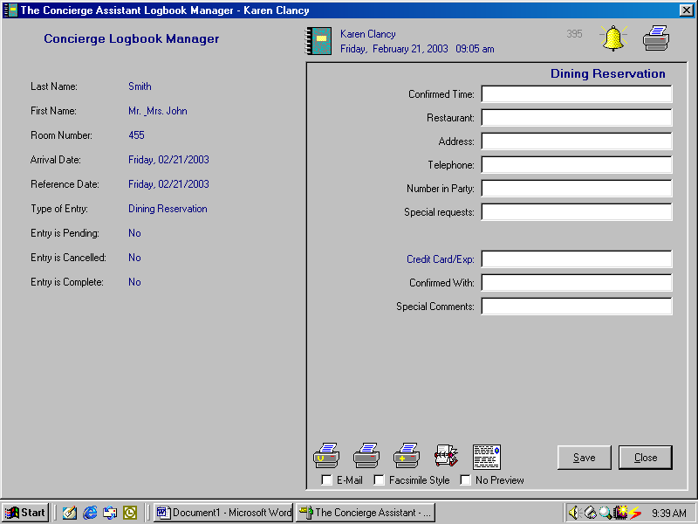
Rolodex
Icon
- Rolodex to use the rolodex to look up a contact double click on the rolodex icon.
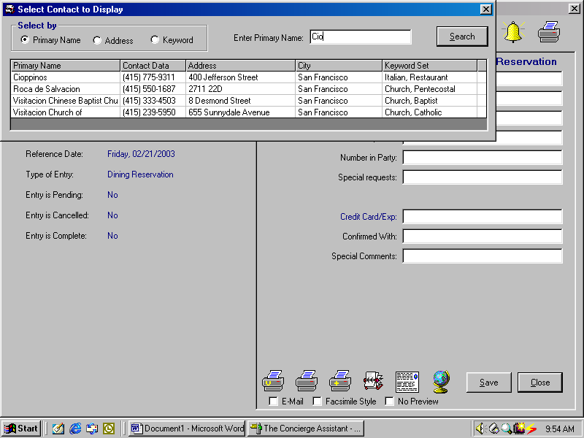
Double click on selected contact

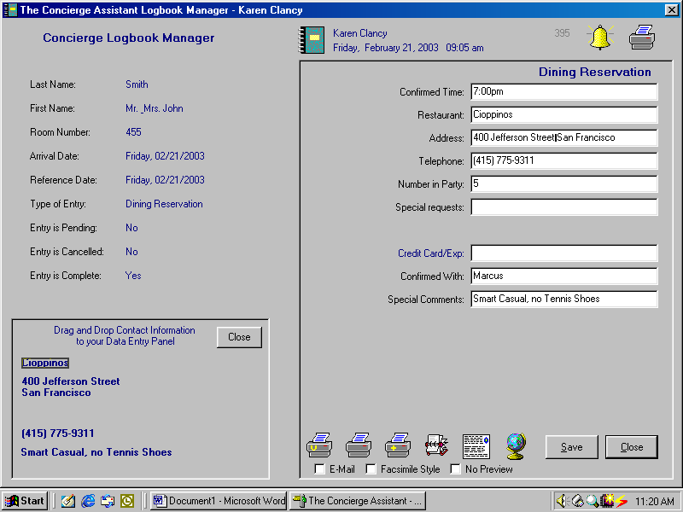
Drag and drop information into appropriate cells

- Drag and Drop Name of restaurant, address, phone number and any other pertinent information. (This can be done by clicking on the restaurant name, holding the button down and dragging the mouse over to the desired area and releasing the mouse button)

- Click save and it will bring you back to the main screen where you first entered the guest’s first and last name.

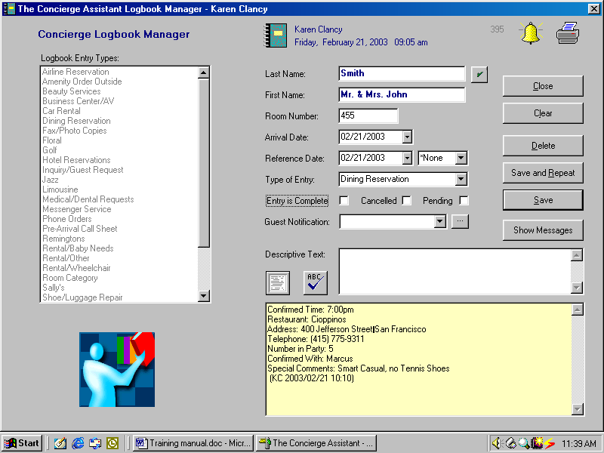
Check the appropriate box to designate status of the reservation

- Status of the Reservation:
  - If none of the three boxes are Checked the entry will appear in Red
  - If the Entry is Complete box is checked the entry will appear in Black
  - If the entry is marked Canceled the entry will appear in Grey with a CXL by the guest’s last name.
  - If the entry is marked Pending the entry will appear in Blue/Green (depending on your properties preference) Please notice all four colors for the status on the reservation.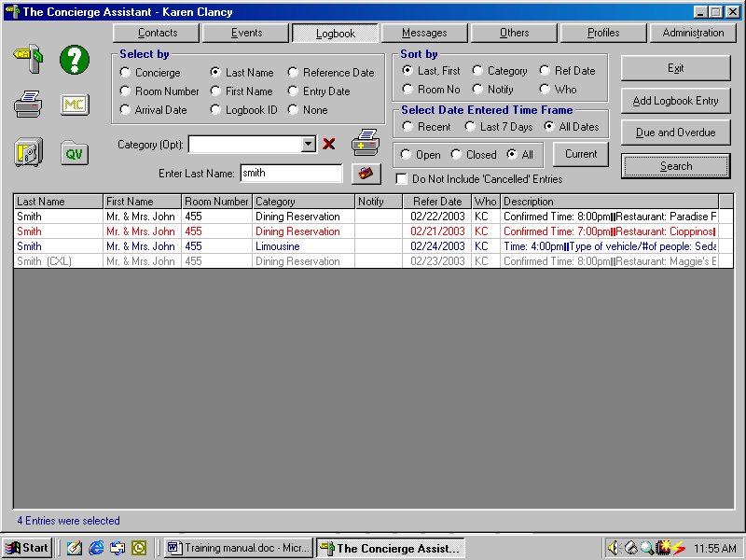
- Guest Notification this box is to let your teammates know if the guest has been informed or not. You can use the drop down box or simply type in a date or the appropriate response.
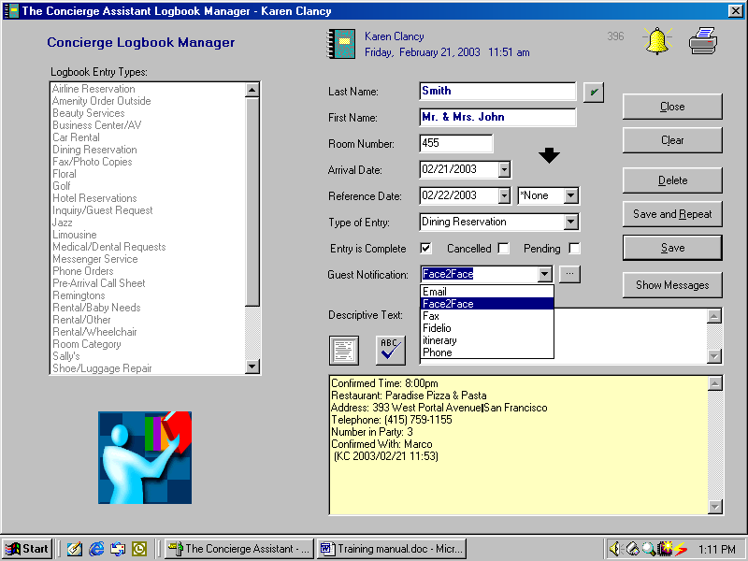
Use to continue to make other reservations for the same guest.

- Always, always SAVE SAVE SAVE!!!!

- Save and Repeat –This function is ideal for making another reservation for the same guest. This way you do not have to re-enter most of the data i.e., Last Name, First Name, Room Number, Arrival Date. You MUST change the reference date and Type of Entry, and then tab 4 times to go to the data entry panel.

- SAVE , SAVE, SAVE!!! And then close to return to the main logbook screen.

- Hit Search or the Enter Key to refresh the screen.

Changing a Reservation

To change an existing reservation
Data Entry Panel Change
Status Change
Notes Regarding Change

- To Change an Existing Reservation in the main screen you will double click on the reservation that you would like to change.

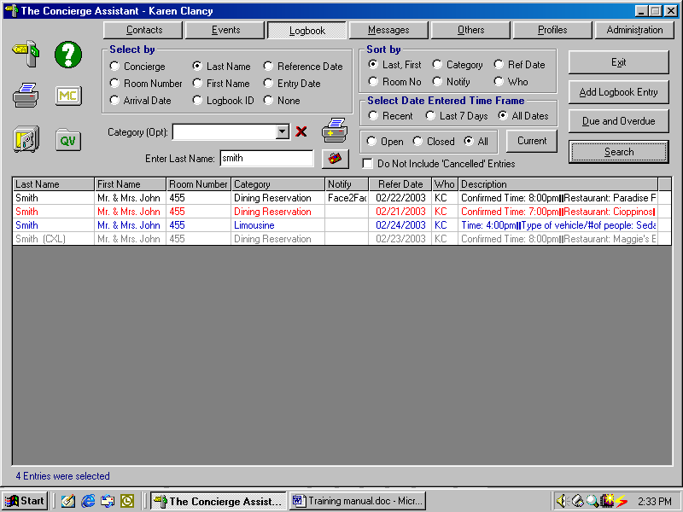
Double Click on existing reservation that needs to be changed

- The easiest way is to double click on the Last Name, First Name or Room Number to bring it up the quickest.

- This will bring up the following:

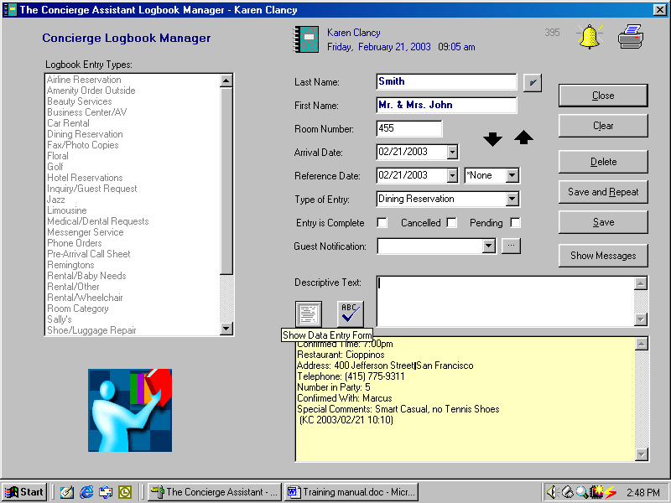
Double Click on piece of paper to go back into the data entry panel.

- Once you double click the piece of paper it will bring you back to the following screen.

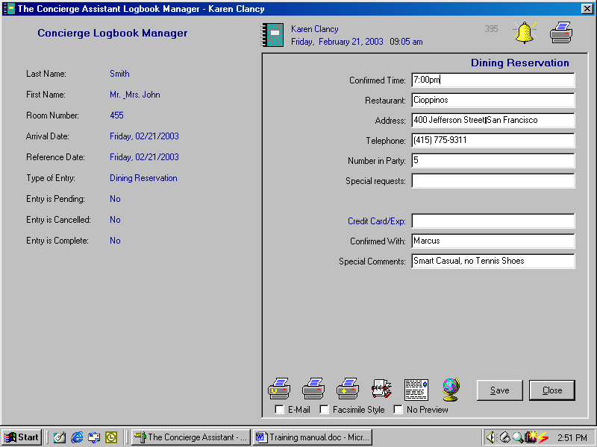

- At this point you can change anything in that data entry panel, i.e., lets say it gets changed from 7:00pm to 7:15pm you would make the change in the Confirmed Time Cell. You can change any cells that are appropriate.
- SAVE and that will bring you back to the reservation screen.
- If there has been a change other than exactly what the guest has requested you should make a notation in the white descriptive text box.

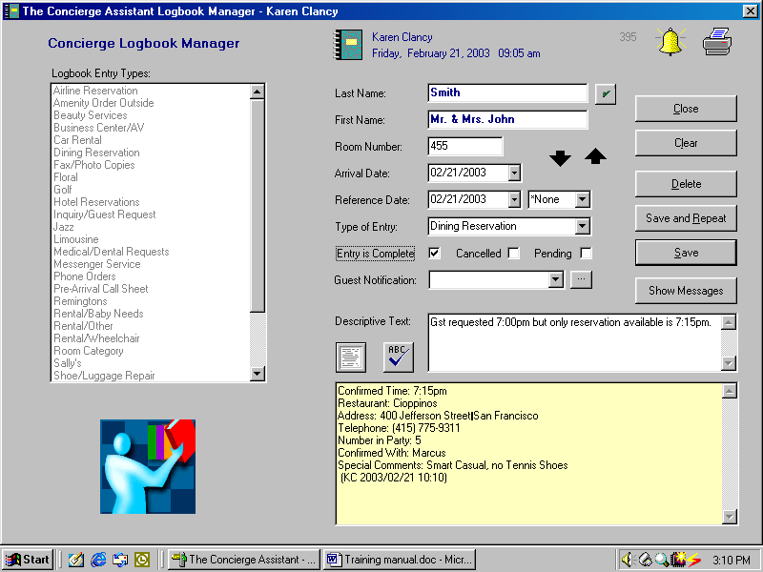

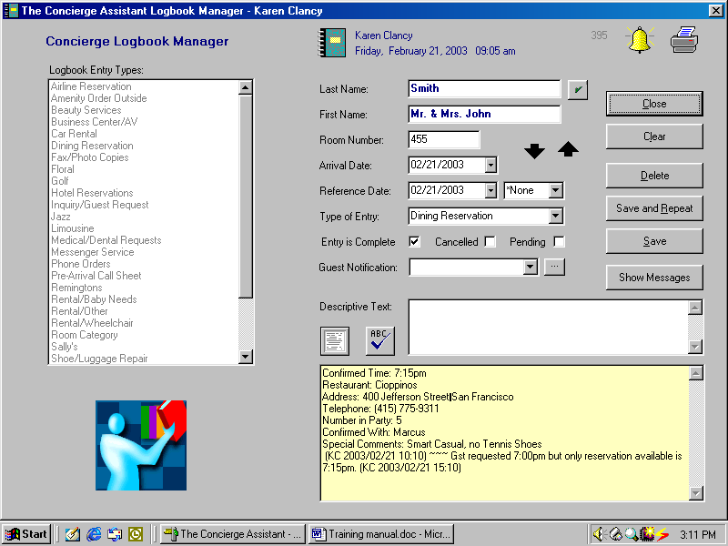

- Once you have either clicked save or hit your enter key it will drop down into the yellow text box after ~~~ (3 tildes) ANYTHING after a tilde will NOT be printed for the guest, this is used for “notes” for the staff on any and all reservations. Everything is always date time and initial stamp by the concierge that made the change to the reservation.
- Mark the Status of the reservation and SAVE, Close.
- Spell Check if you are using spell check the reservation information must be in the White Descriptive Text Box.
- Once you hit the close button it will take you back to the main logbook screen.

To Cancel a Reservation
- Bring the reservation up exactly like changing the reservation.
- Change Status of the reservation by clicking the cancelled box, please note that the complete box will also stay checked that is so the computer knows to change the color of the reservation.
- Just like in changing the reservation always make note of who cancelled the reservation and why as shown in the following.

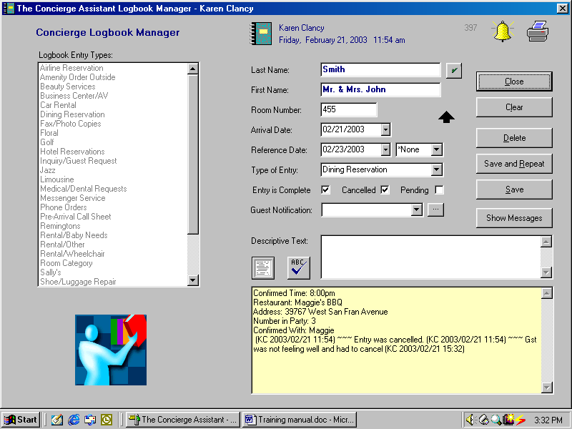

- As with most changes it will always be date, time and initial stamped.

- To Change Status to Pending

- Bring the reservation up exactly like changing the reservation.

- Change Status of the reservation by clicking the Pending box, pending is when something still needs to be done with the reservation. See the following:

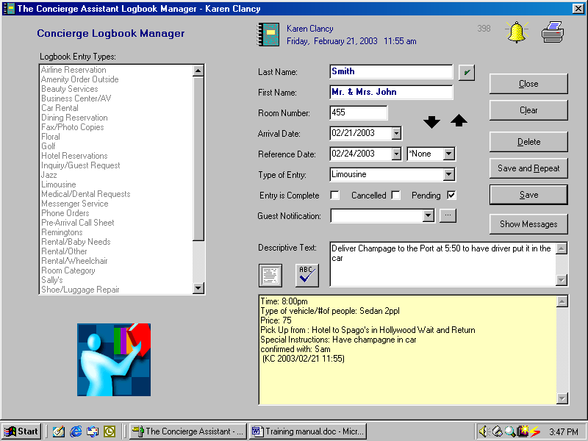

- Once you have saved the information it will then again drop down to the yellow descriptive text box and be date, time and initial stamped.
- The best practice is then to send yourself or you team members a message in regards to this logbook entry and that is covered on page ( ) further in this document, also, always make sure you tell your teammates why it is pending by making a note in the white descriptive text box.

Confirmations, Itineraries, Note Cards, Miscellaneous charge forms and Vendor Reservation Sheet

- Single Item Confirmations, to print out a single item confirmation double click on the entry that you would like to print up.
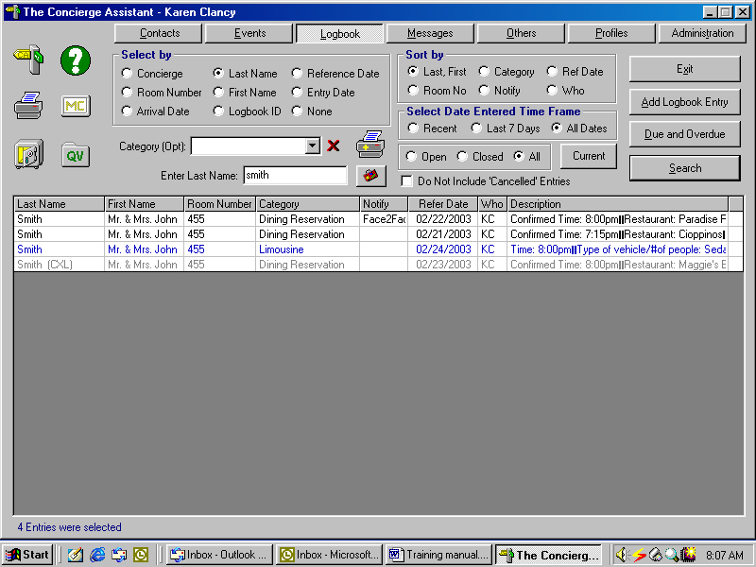
Double-click on the entry that you want a confirmation for.

- That will bring you into the logbook entry
- Double-click on the “piece of paper” to take you into the Data Entry Panel.
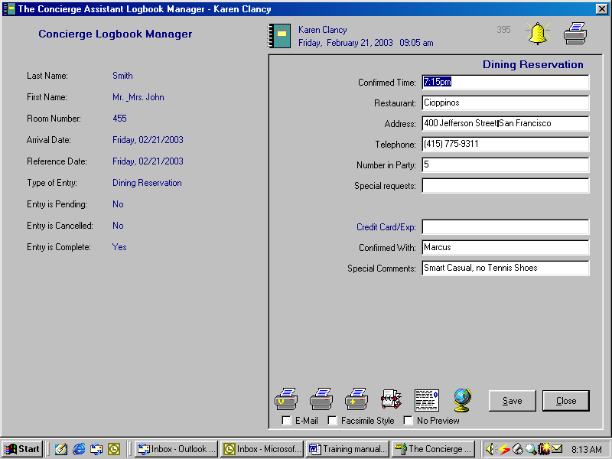
Double-click printer with the yellow plus sign for single item confirmation

- Double-click the printer with the yellow plus sign to bring up a print preview of the Single Item Confirmation.

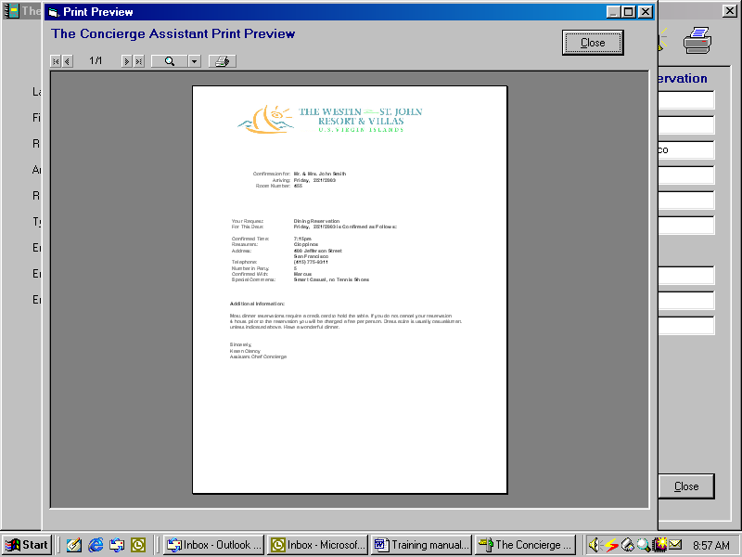
Click on the printer icon to send to the printer.

Shortcut From the “Main Logbook Screen”
- Right mouse-click on the logbook entry that you would like a confirmation for. Release the right mouse button
- Pull the mouse down till the shortcut is highlighted in dark blue
- Left mouse click. Please note that there will be no print preview and it will go directly to the printer.
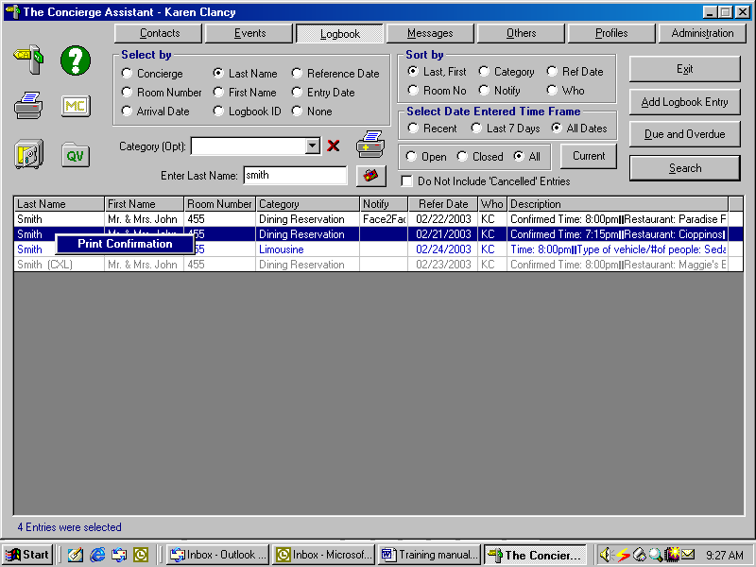

Itineraries

- To print a multi item itinerary in the main Logbook Screen. Select by Last Name

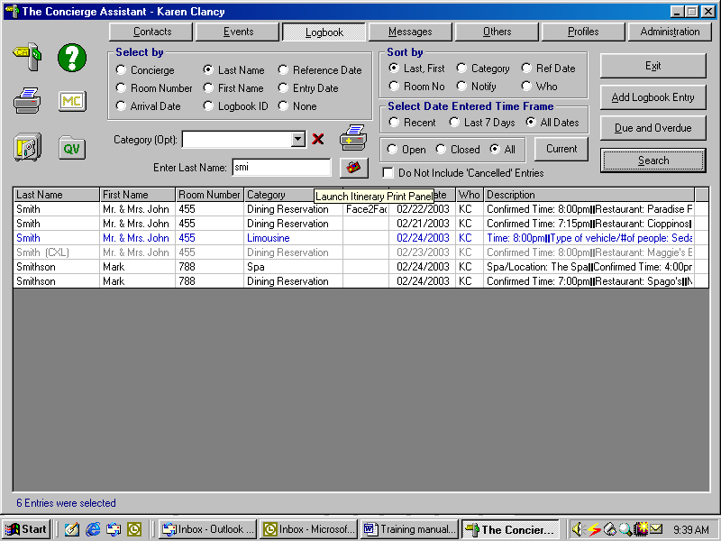
Itineraries can ONLY be done by Selecting by Last Name
Single-click on the suitcase (itinerary icon) to build an itinerary.

- The next screen you must click on the guest that you would like to build an itinerary for.
- Double-click on the guest name in the box on the right-hand side.
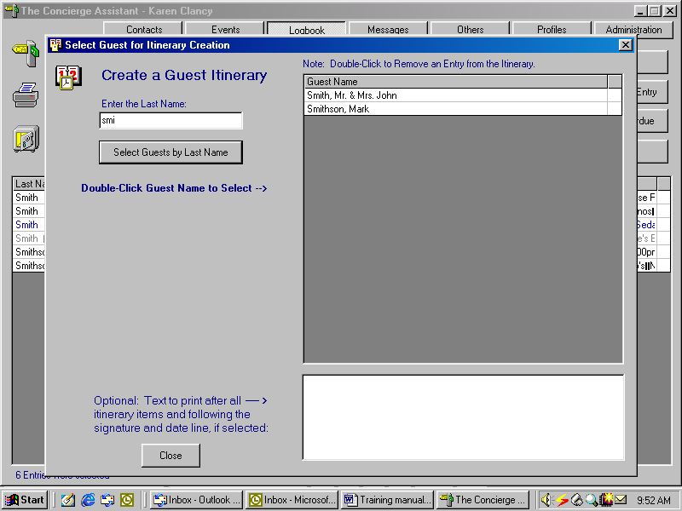
Double-click on the guest that you would like to build the itinerary for.
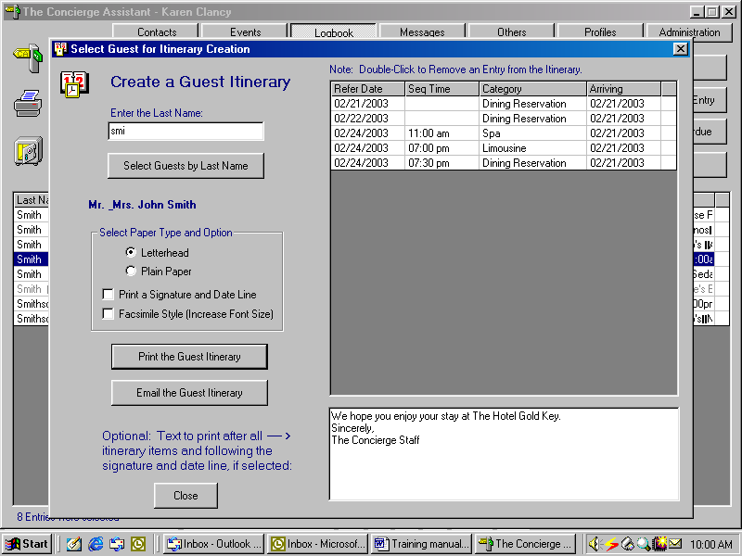
If you want to take any items off the itinerary due to it being a surprise or if the guest has already done the activity, just Double click it off the screen.
Seq Time: This is to over-ride the alphabetical element and sequence by time.

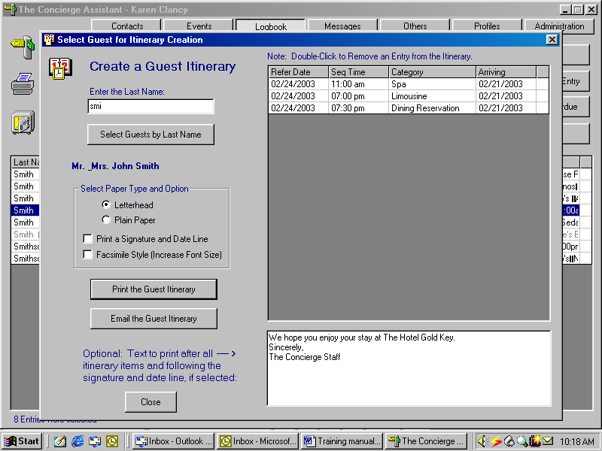

- Sequencing Items the program automatically sorts by day first, then alphabetically. If you want to over-ride the alphabetical sequence and sort by time you must use the sequencing element in the reservation panel on each entry.
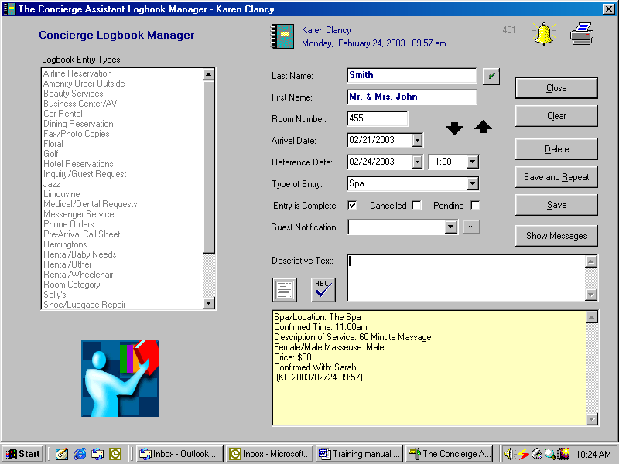
Sequencing the itinerary items by using this cell

- Please note that this sequencing element will NEVER print out for the guest.
- When double-clicking of any element from the itinerary, if you make a mistake just click on the button called “Select Guests by Last Name” and it will take you back to the original screen where you select the guest and it will take you back to the beginning.
- The large white box at the bottom of the Create a Guest Itinerary screen is to personalize the itinerary for the guest. It will print up at the bottom of the Itinerary.
- Then select either Print the Guest Itinerary or Email Guest Itinerary (If you have Outlook).
- Again, the program will always do a print preview prior to printing up the screen.
- Once you have reviewed the itinerary then go to the printer icon and click and send to the printer.
- There are also two options for your logo through the Administration Tab in The Concierge Assistant. You may use your properties letterhead or have the logo automatically printed out on all Printed items for the your guests.
- Please see the next screen to see the print preview screen.
- In the itinerary screen you also have the option to select paper type and to print a signature line and to increase the font (for older fax machines).
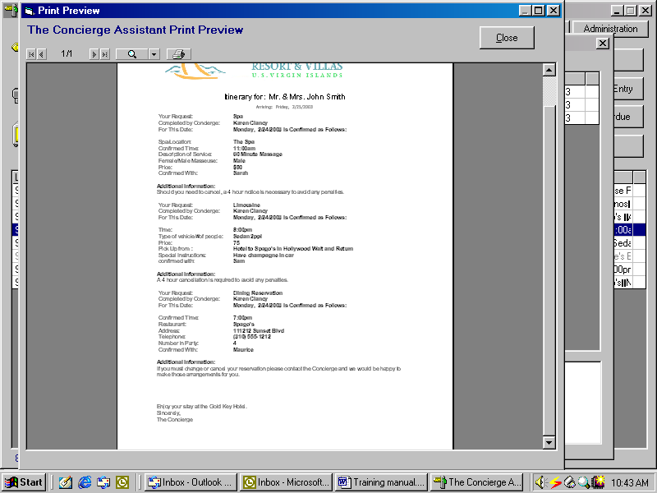
Click to send to the printer

Note Cards must be set up by your administrator, here is one example.

- To print up a confirmation card, proceed just as if you are going to print up a “Single Item Confirmation”
- Double-click on the Note card Icon.

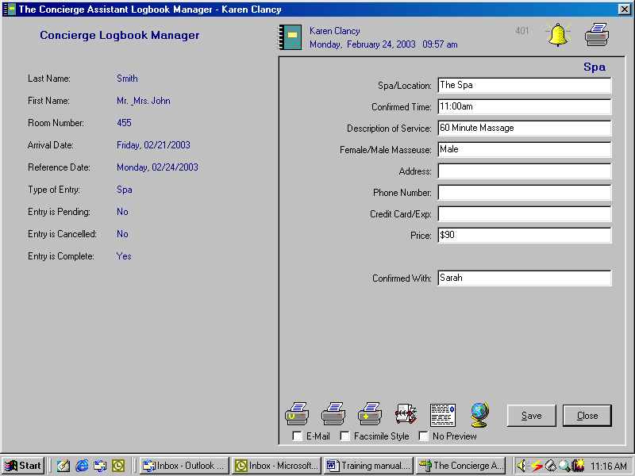
Note card Icon
Vendor Reservation Form
Micellaneous Charge Form
- As in most of the printed material in The Concierge Assistant you will be shown a Print preview and then you will have to go to the Printer Icon to print the Note Card
- The Printer with the “Yellow V” is for Vendor Reservation Sheet. The difference in the Vendor Reservation Sheet is that the Credit Card information will print out for the Vendor but will not print out for the guest (these are any of the data entry elements that are in Dark Blue, i.e., Credit Card, Broker Information ect).
- Micellaneous Charge Forms are used to have a place for a signature of the guest, to be able to charge anything to the guest and to have written confirmation with their signature.

Examples of all Three

Note Card

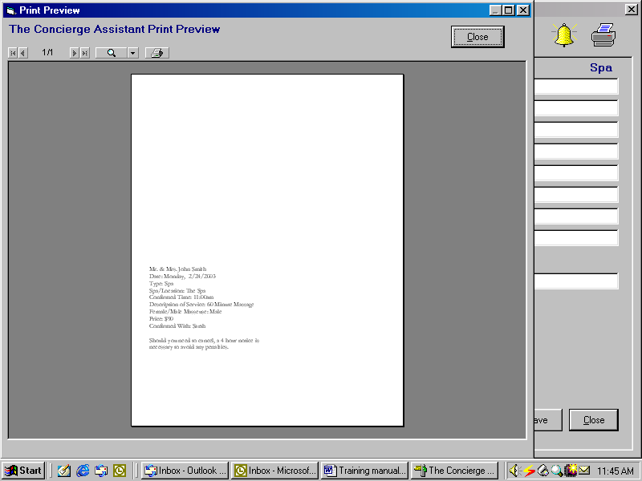

Miscellaneous Charge Form

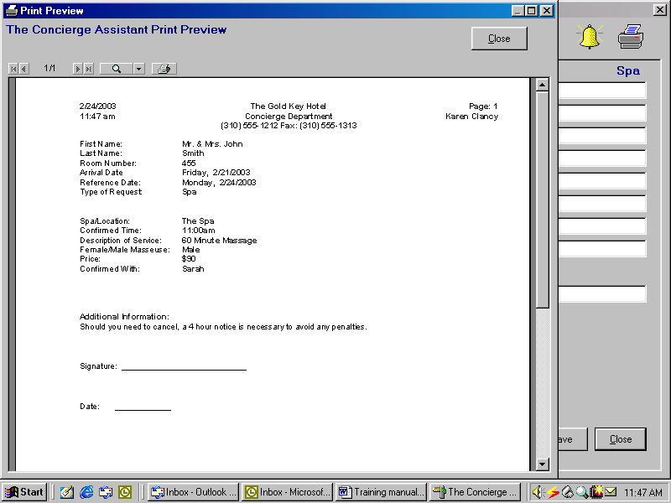

Vendor Reservation Sheet

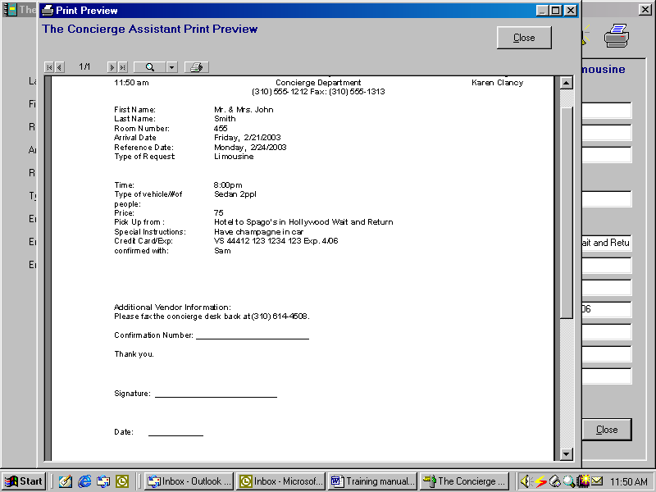
Helpful Hints

To Start Your Shift
- Go to Logbook Select By Reference Date (put in today’s date), Sort by either Last Name, First Name or by Category. This will show you what is going on for today this is like having your logbook open to today.
Example:
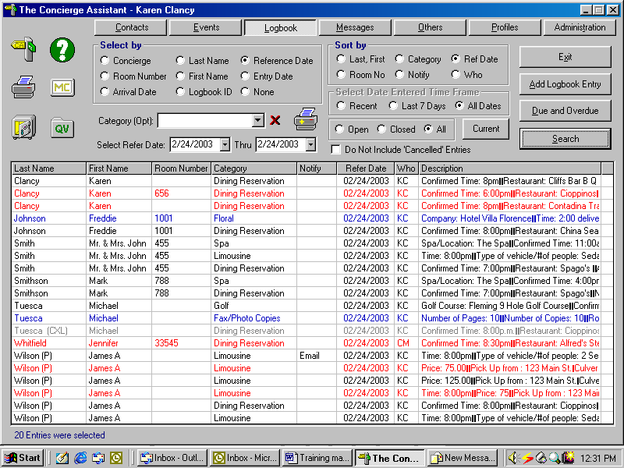

- Make sure that everything is completed for the day.
- You can also put in a Category in the cell right above the reference date in order to limit the search to just that category.

Another best Practice
- To find out everything that is Open in your system, Select by None and sort by Reference Date. At the lower right there are Three buttons Open, Closed and All, Select the open button and everything Open or Pending ONLY will appear. See Example.

Explanation of the Main Logbook Screen

Select by Box is the first thing to choose when starting your search function.

Select By

- When you are beginning your search for entries you must always select by first.
  - Concierge it will automatically bring up the name of the concierge that is logged on to the program. By either using the drop down arrow or by beginning to type you are able to select any concierge that has a log on in the system.
  - Room Number will bring up a cell that you will then type the guest’s room number in and any guest that has been in that room since you have archived will come up.
  - Arrival Date when putting arrival dates into the field in the guest reservation it will bring up every guest that has that corresponding arrival. This is great if you are printing up itineraries for incoming guests.
  - Last Name when the guest approaches the desk you can bring it up by the last name of the guest. A best practice is to only put a few letters of the last name of the guest to try to avoid misspelling of the guest’s last name.
  - First Name if you know the guest’s first name to try to recall what the guest has done during their stay.
  - Logbook ID every single logbook entry has a unique identifier number located at the top right-hand side of the logbook entry (by the bell and the printer in grey), this number can be used to give to either guests who are insistant on having a confirmation number or to be used as a voucher number.
  - Reference Date is the way most properties run the application from day to day. When you bring it up by reference date for today’s date it will bring everything up that is happening that day.
  - Entry Date is the date that the entry has been made by the Concierge. That Date Appears at the top of the data entry page.
  - None using the None box is a best practice for finding out what is still open in the system. Click on None and to the lower right next to your Search key there are three buttons Open, Closed All. If you select on the Open button it will bring everything up in the system. As Shown:

To see all your OPEN entries

